

**Downloading & Processing ACC Payments**

**Go to the supplier menu on the left hand side and select PAYMENTS ADMIN**

**Depending on when you last ran your payments, choose how far back you wish to search for payments – 1 day to 4 weeks range. Then click FETCH NEW REFERENCES**

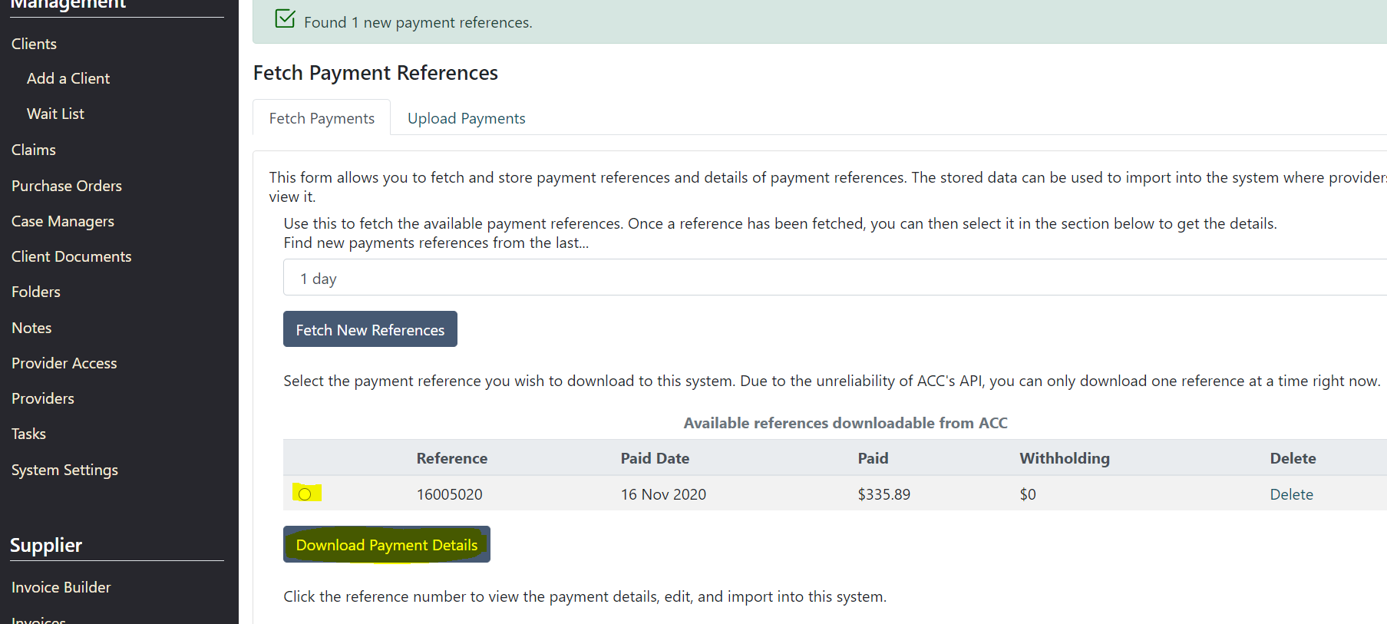

**Once the references have been fetched, download one by one.**

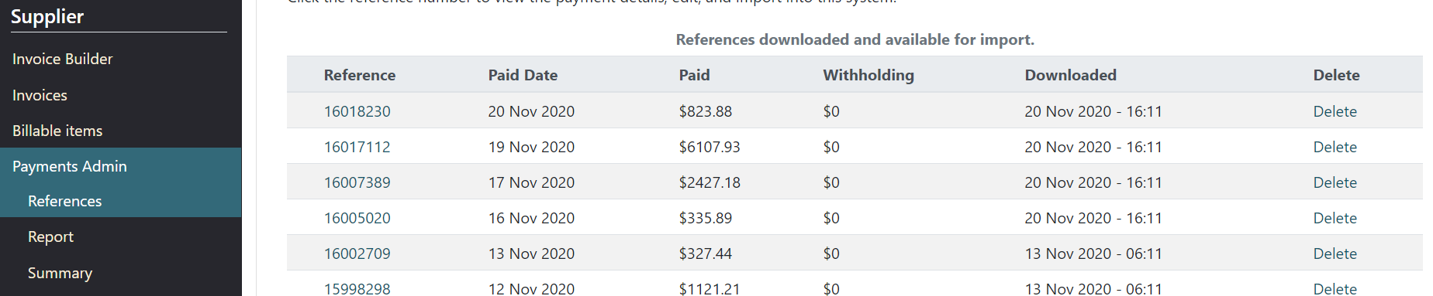

**Once all have been downloaded, select the oldest, or earliest in time, clicking on the reference number to open for processing.**

**Once opened, you need to request the system auto-match the information on this payment advice from ACC with the billing information in CMS.**

**To do this, tick all items, then click 1. Auto-Match all Rows**

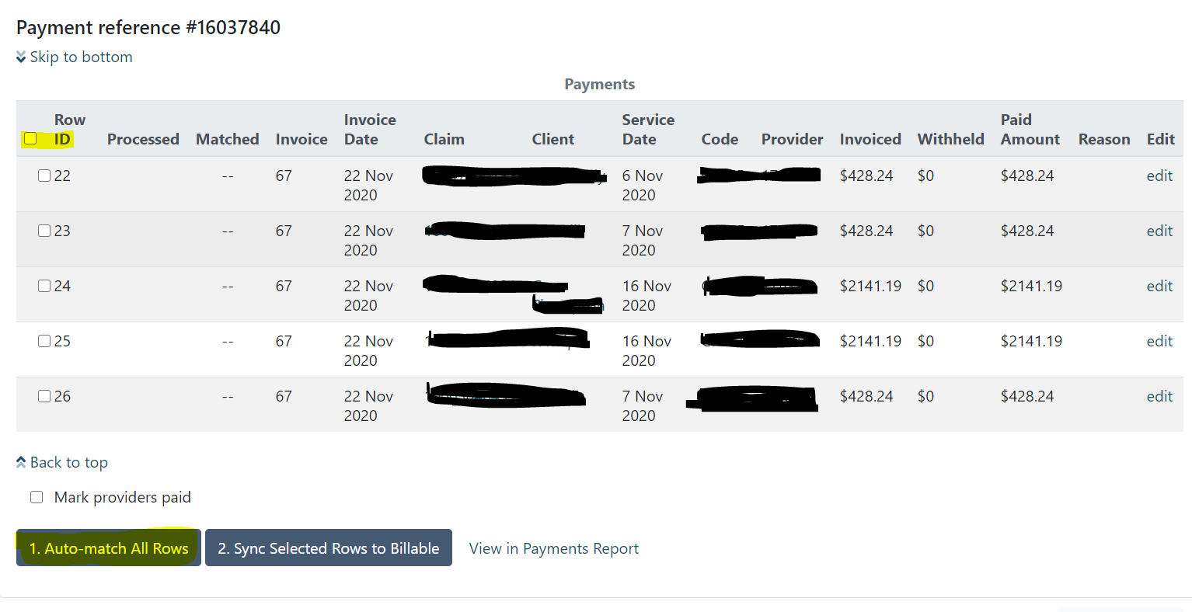

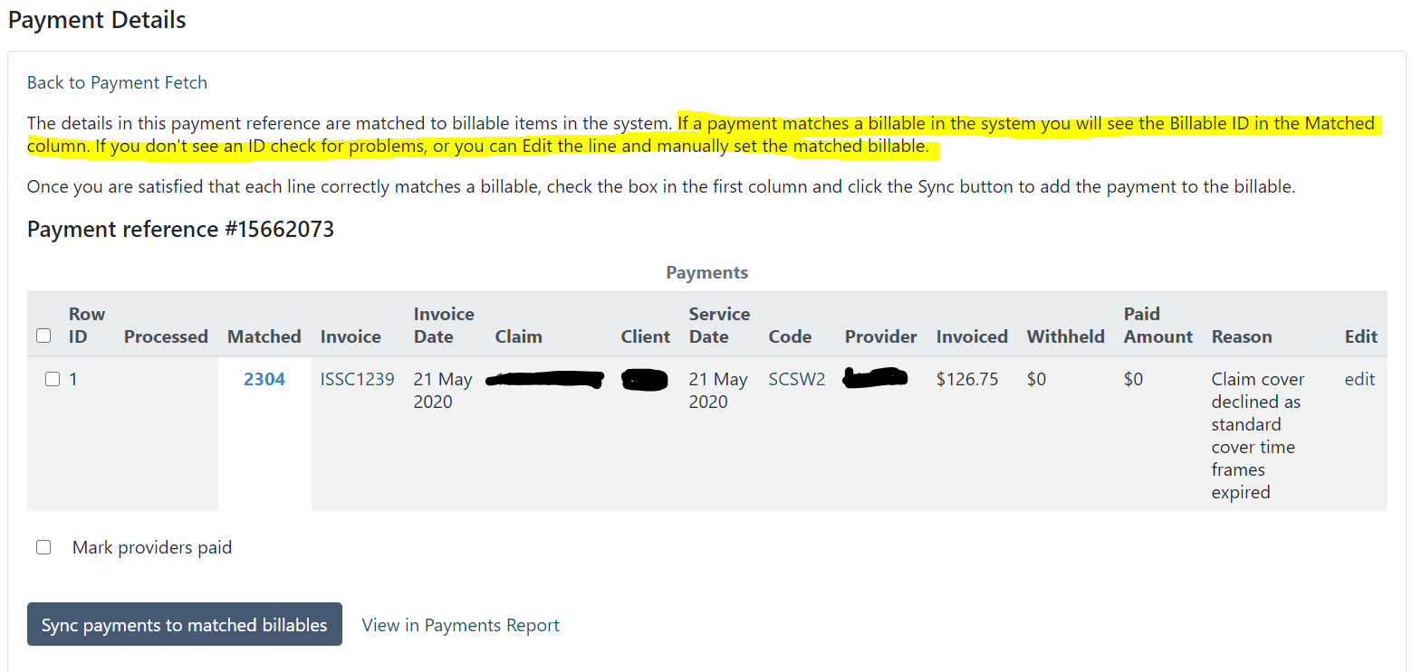

**If the lines have not all matched, read the error messages - these which tell you which lines and client’s billing have not matched.**

**If it is a duplicate line, copy the whole line on the error message, click edit to the far right of each line item and paste the line into the field at the very top of the edit page, click into the pop-up that appears underneath, then SAVE.**

**If it is not a duplicate line, it means that the information that ACC have paid on is different to what is in CMS.**

**This could be:**

**Slight variation in name eg. Hyphenated name, names all in capitals, change of name, use of middle name on CMS rather than first name if client prefers.**

**Hidden space before or after claim number, first name, last name.**

**Code paid on is different**

**Date paid on is different**

**Claim number is different.**

**Once you change the information on CMS to match ACC, you should find when you run the auto-match again that the billable ID will populate.**

**If everything has matched, tick ROW ID, then tick 2. Synch Selected Rows to billable.**

**This marks each billable as paid by ACC.**

**Once you do that, go to VIEW IN PAYMENTS REPORT.**

**Tick to select all lines, then enter the date you wish to pay providers, then MARK PROVIDERS PAID.**

**ONLY when you have processed all payments for a chosen pay date, click GENERATE BCIs.**

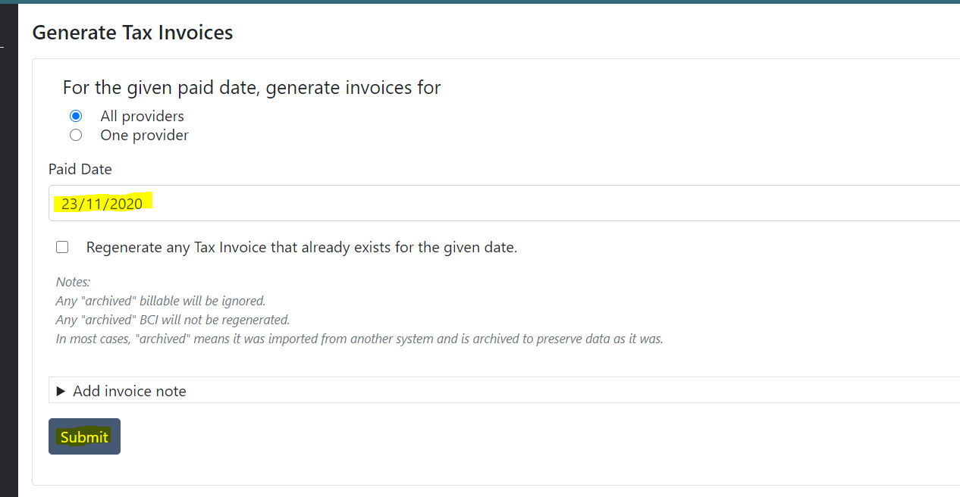

**Enter the date you are paying the providers (that you have already used for the payment processing), then click SUBMIT**

**Once the BCIs have generated, go to SUMMARY**

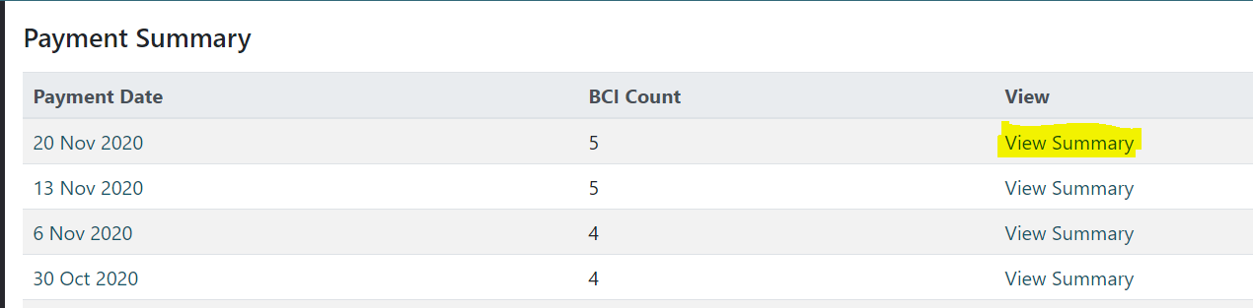

**Click view summary.**

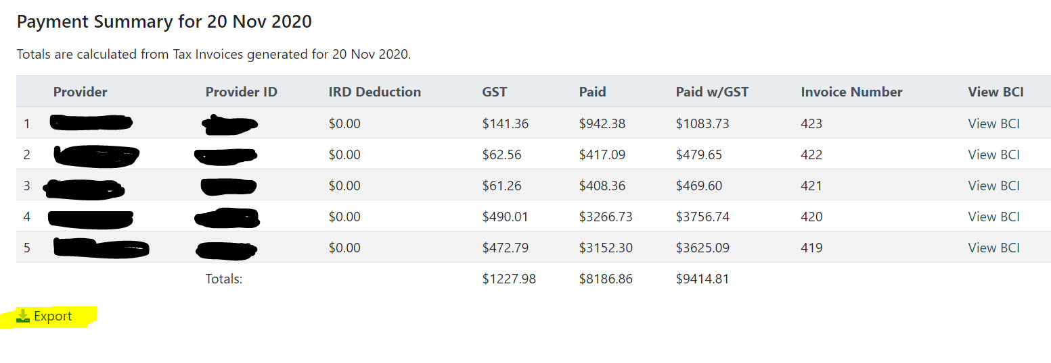

**You have the ability to export this to a spreadsheet or csv.**